Record No: 0525
SIR JAMES SOMERVILLE

Son of Thomas Somerville (0519) and Catherine King (0520).

Birth:
Marriage: 2 Feb 1713, St Audeon’s Church, Dublin, Elizabeth, dau of William Quaile
Death: 16 Aug 1748.
Buried: 19 Aug 1748, St Audeon’s, in the family vault.

Notes:
SR1636: Marriage & burial research, Parish Reg. Records Office.
SR1374: Will dated 12 May 1740; proved 18 Feb 1749 by Robert King
Grant of Administration dated 24 Feb 1724 to Sir Quaile Somerville (0534)

SR1775: 1720-21: High Sherriff, Dublin
17 May 1729: Alderman
& SR1269: 1736-37: Lord Mayor
SR1775: 1720-48: M.P. Dublin
9 Sept 1737: Knight
SR1026 14 Jun 1748: created Baronet

SR1775: Col. of the Dublin Orange Foot Regiment.

SR1775: Succeeded to the Meath Estate of his uncle James King of Corrard (d. 25 Mar 1726), a
merchant of Dublin.

Source: Somerville Index.

Additional Research:

Somerville was built by Sir James Somerville, who was Lord Mayor of Dublin in 1736 and also served as MP for the city. The plan of the original house can be traced today at basement level, where a series of vaulted rooms survive with joinery details that suggest a date of c. 1730. The back of Somerville was at that time four windows wide, while the front had five.

A two-storey, stone-built stable yard lies to the north of the house. At the centre is a pedimented archway surmounted by an octagonal castellated tower. A pair of houses flanks the archway, with tripartite windows looking into the courtyard.

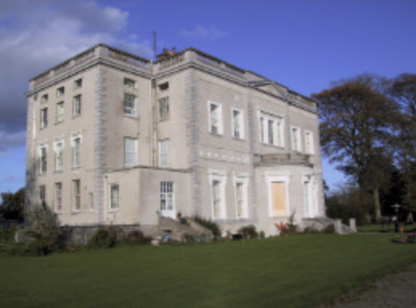
Somerville, Co Meath

On the western drive, Archway Lodge is a high-rusticated arch flanked by pilasters, with substantial square rooms on either side.

The landscaped grounds include areas of protected woodland, a walled garden, and ice house.

Adapted from: http://www.meath.ie/LocalAuthorities/Publications/PlanningandDevelopmentPublications/CountyMeathPlanningPublications/CountyMeathDevelopmentPlan2007-2013/File,3485,en.pdf

